Rollins College

Databases Project:

Eventique Harmony

Developed by Team Triad: Karam Hack, Nicole Edoziem, Xandria Bramble

CMS 375 - Database Design and Development

Dr. Sirazum Tisha

April 23, 2024

# **Introduction**

The topic of this project is Eventique Harmony, which is an event management system. The purpose of this project is to make the life of event organizers a whole lot easier. It’s a one-stop shop for keeping track of who’s attending the event, the venue where it could be taking place, and the schedule or itinerary of the event. By having everything accessible in one place, this management system prevents having to flip through files, search through emails, or go through different apps to find details of events. This website is like a personal assistant that keeps everything organized. For attendees, it means less confusion. The target users of this website are people who are either event organizers or are attending events. In retrospect, this website is for everyone because everyone will have to participate in an event at some point.

# **Methods**

This project was developed using SQL through MySQL Workbench and connected with PHP through Visual Studio Code. MySQL Workbench holds the database for the events, list of users, schedules, and venues. The PHP files execute the website as a local host on the machine and display all the information in a user-friendly way so that the website is understandable and easy to use. There’s a file for the homepage, creating an event, updating a user, styling the website, deleting an account, and registering a person for an event. Nicole created the schema for the database, Xandria created the design for the website, Karam made the coding files for the website, and Xandria and Nicole contributed in any way they could regarding the functionality of the website.

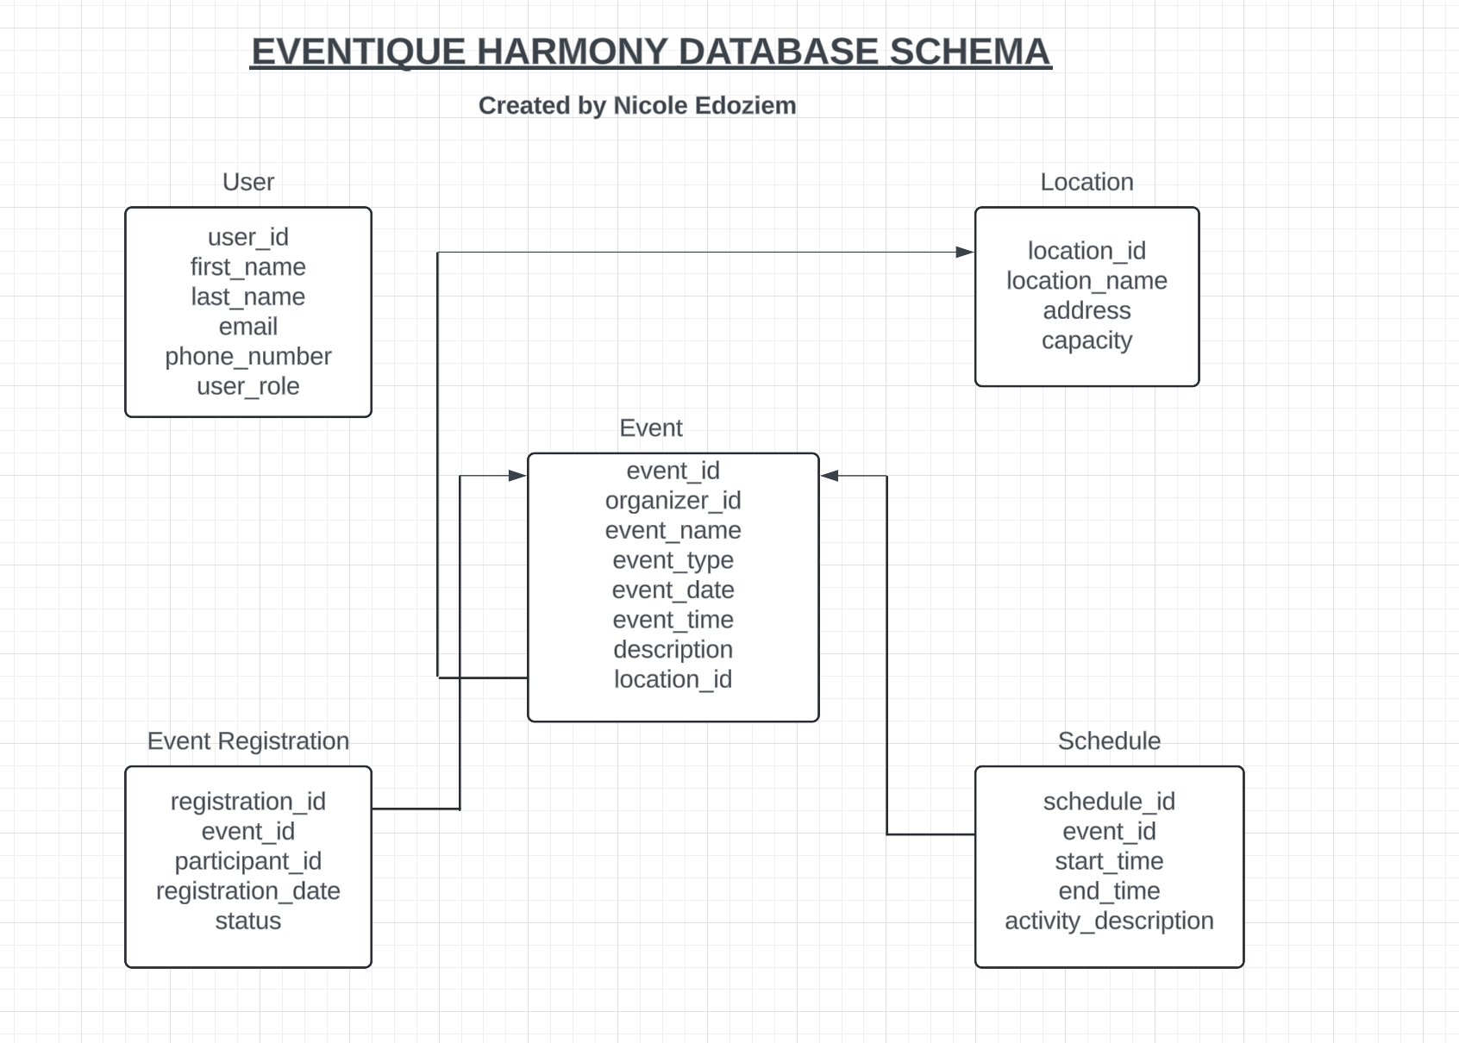

E-R Diagram

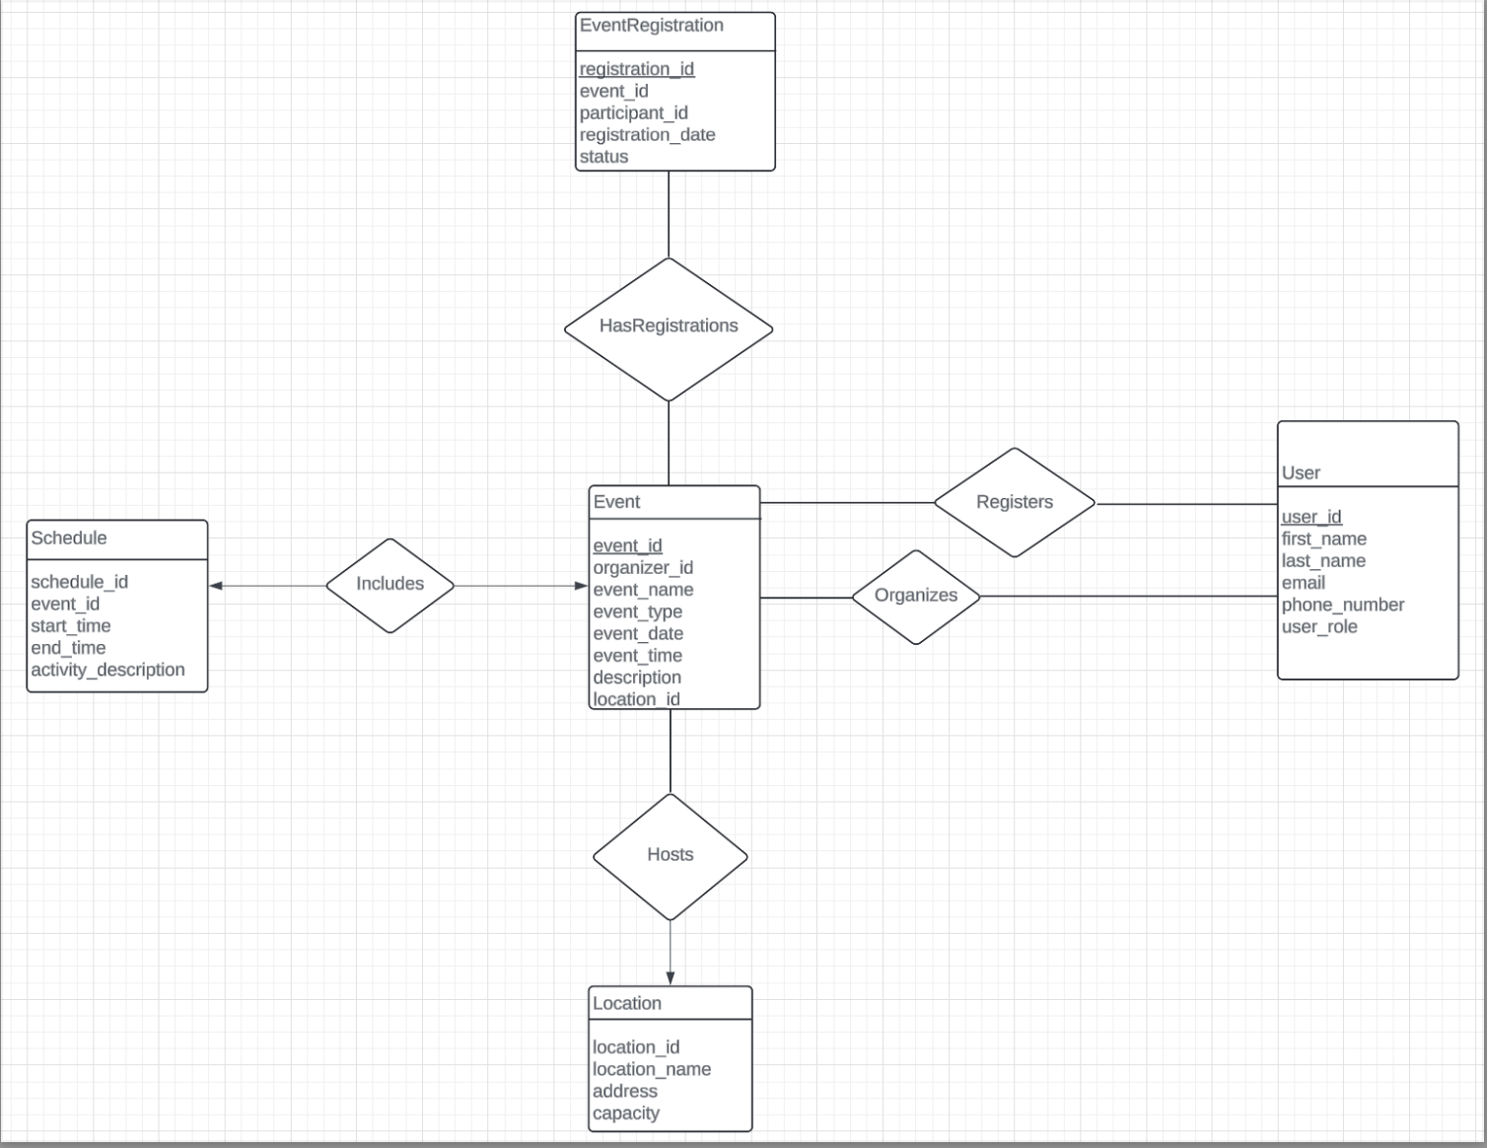

Code

Attendees_Page:  
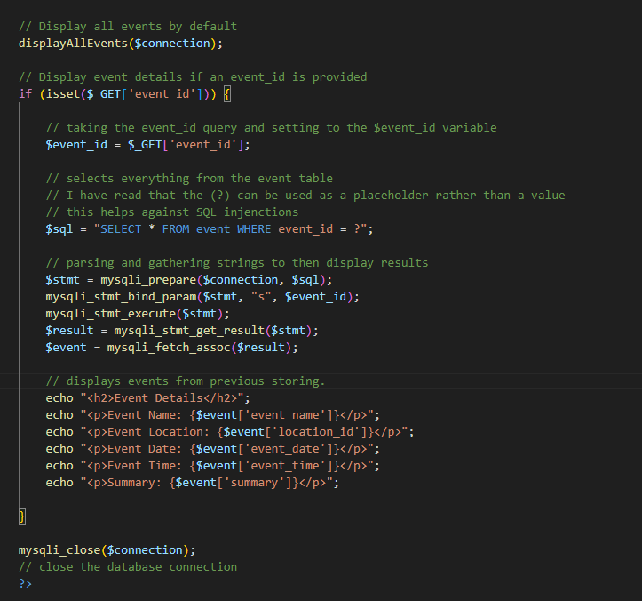

The code to display all the events from SQL’s event table  
  
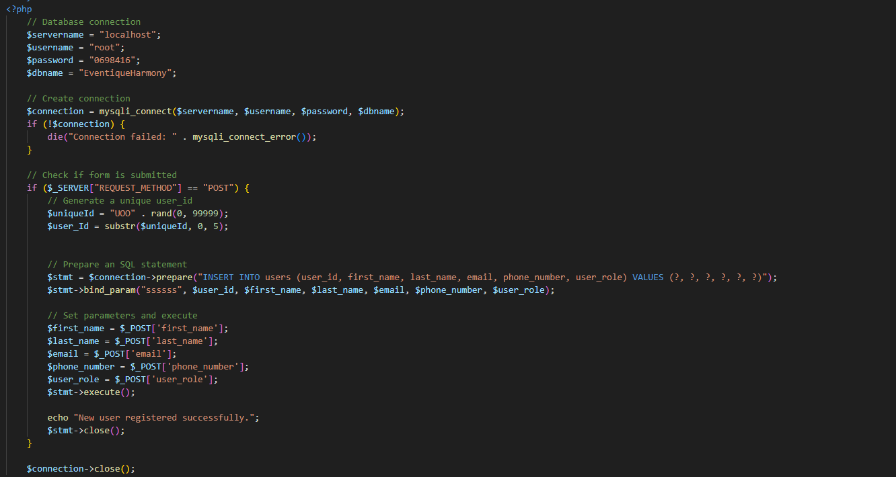

^ The homepage code, for users to register and select roles (registering)

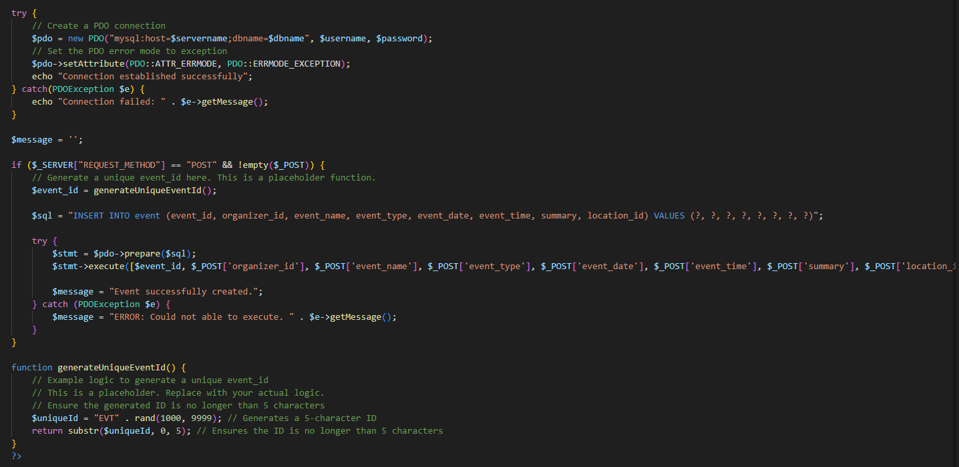  
^ For creating events and also getting input from the user

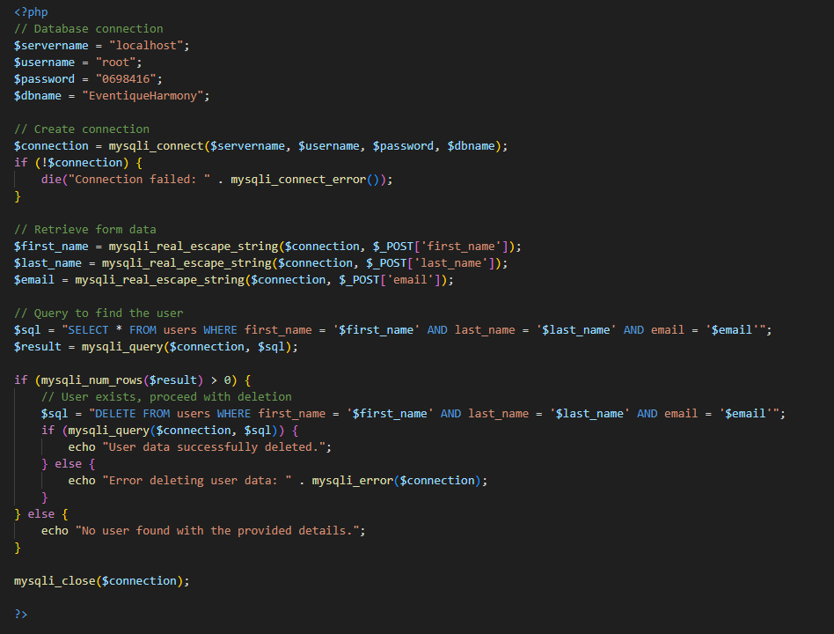^ code to delete user data

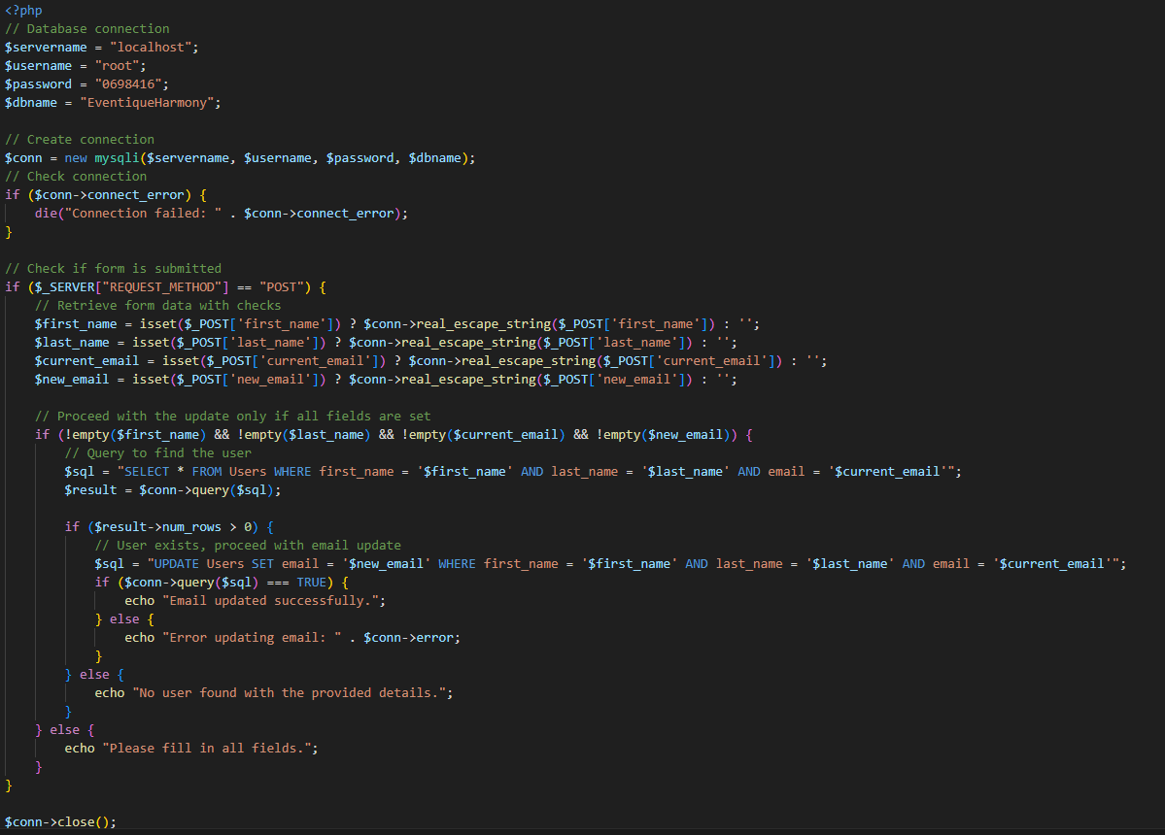^ for updating user info based on user input

# **Experiments**

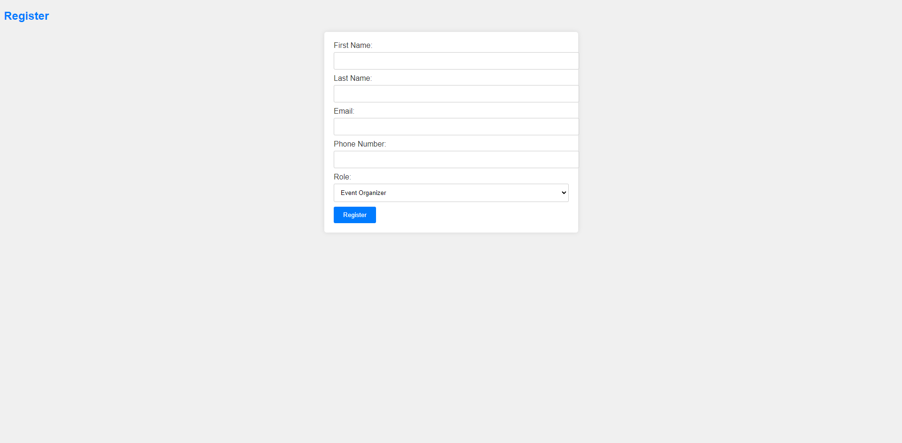

^ This is the page that users see when they first drop in. This will have them register and declare their role.

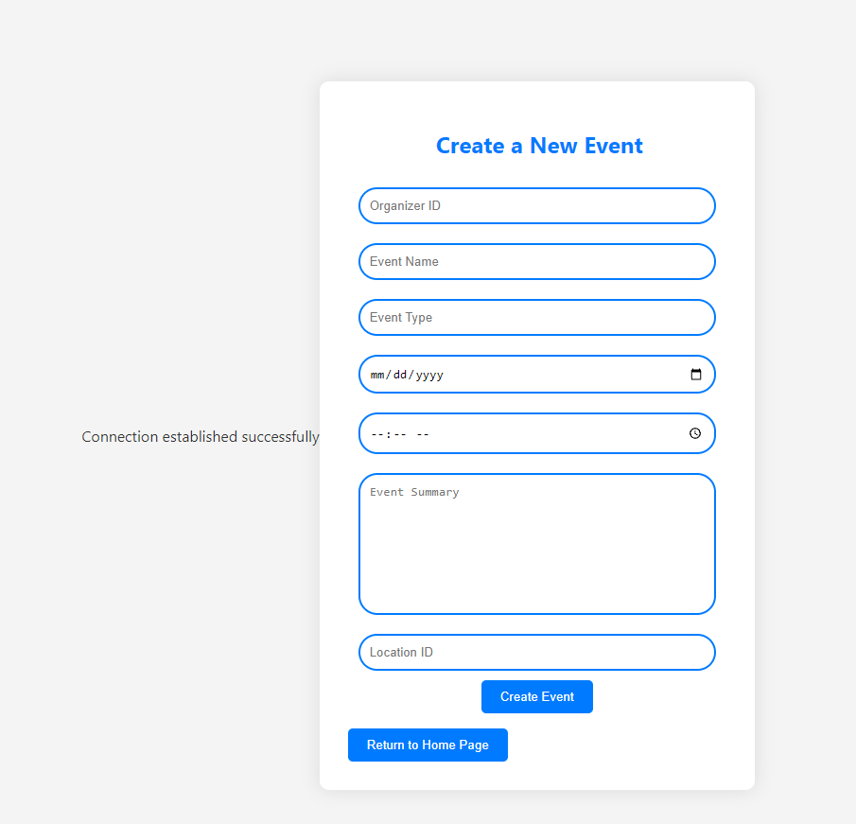  
^ When user selects, “Event organizer”, they will be directed to this page and insert event info to display for attendees.

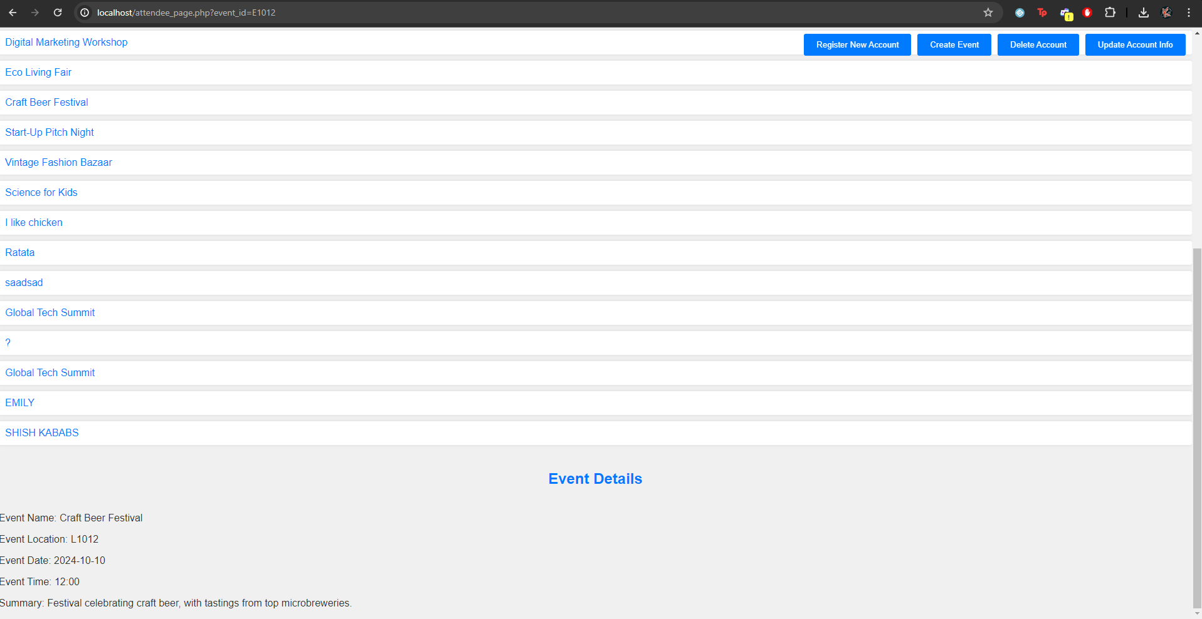  
^ Attendees are able to select and view event details.



^ Users are able to delete their info and remove themselves from events from doing this process.



^ Users are able to update their email information.

# **Discussion & Conclusion**

Through this project, we learned a lot about MySQL and PHP and how to connect both of these languages to produce an outcome that we want. We were also able to apply the concepts we learned in class to this project. Working on this project really gave us the creative freedom to come up with a concept and we’re glad that we were able to build a database management system for something that was relatable to us.

We were able to implement the four important features (insert, update, delete, and select) but in terms of what doesn’t work well, before we delete events, we would want to work on removing the error messages that show on the bottom of the screen before being deleted.

In the future, we would also want to add more security measures to guard our system against SQL injections. We would also like to make the user interface more aesthetically pleasing and user friendly. Hopefully, we can expand on this project and have it be an actual system being used in the real world.

In terms of challenges faced, we found it difficult picking what we wanted to do but we brainstormed and finally narrowed down our ideas and settled for the event management system. We definitely stumbled a bit with the initial connection between MySQL and PHP. We overcame this by working together and problem solving, Karam also struggled a bit with the delete function but with teamwork and a little bit of research, he was able to figure it out successfully.

# **References**

We used chat gpt to come up with the Eventique harmony name and some debugging

<https://www.w3schools.com/sql/default.asp>

# 

# 

# 

# 

# 

# 

# 